

Design and 3D Printing

|  |  |  |  |
| --- | --- | --- | --- |
| **Arm & Joints Task 1**  **Date:18/06/2020** | | |  |
|  | |
| **Names: Supervisor:**  Faris Al-Mujalli Eng.Wessam Munshy  Abdulmalik Al-Mujalli |

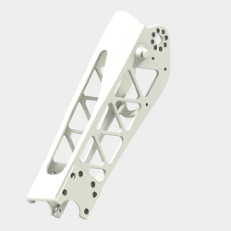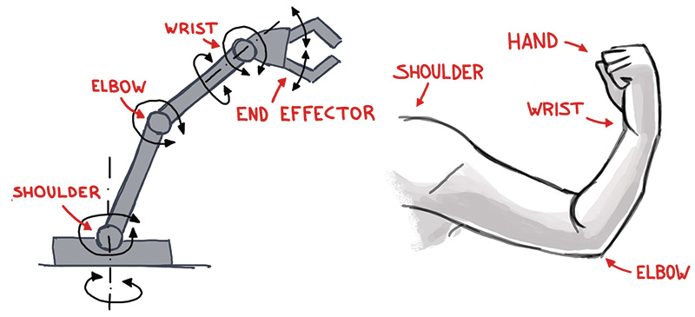

#### Motors Compare

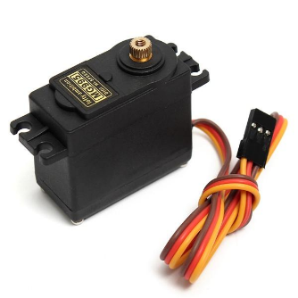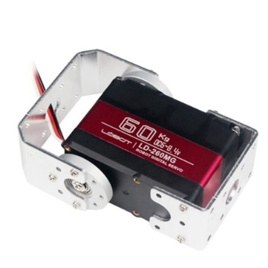

|  |  |  |
| --- | --- | --- |
| Name | LD-260mg | MG 995 |
| **Dimension** | 65*30*48mm | 40*19*43mm |
| **Weight** | 163 grams | 69 grams |
| **Rotation** | 180 Degrees | 180 Degrees |
| **Torque (Max)** | 70 kg.cm (8.4V) | 15 kg.cm (6V) |
| **Torque (Min)** | 58 kg.cm (6V) | 13 kg.cm (4.8V) |
| **Speed (Max)** | 0.13s/60º (8.4V) | 0.13s/60º (6V) |
| **Speed (Min)** | 0.17s/60º (6V) | 0.17s/60º (4.8V) |
| **Price** | High | Low |
| **Critical Difference** | Has shaft & bearing | Only shaft |
| **The Choice** | Checkmark | Close |

#### Dimension Details of Motor

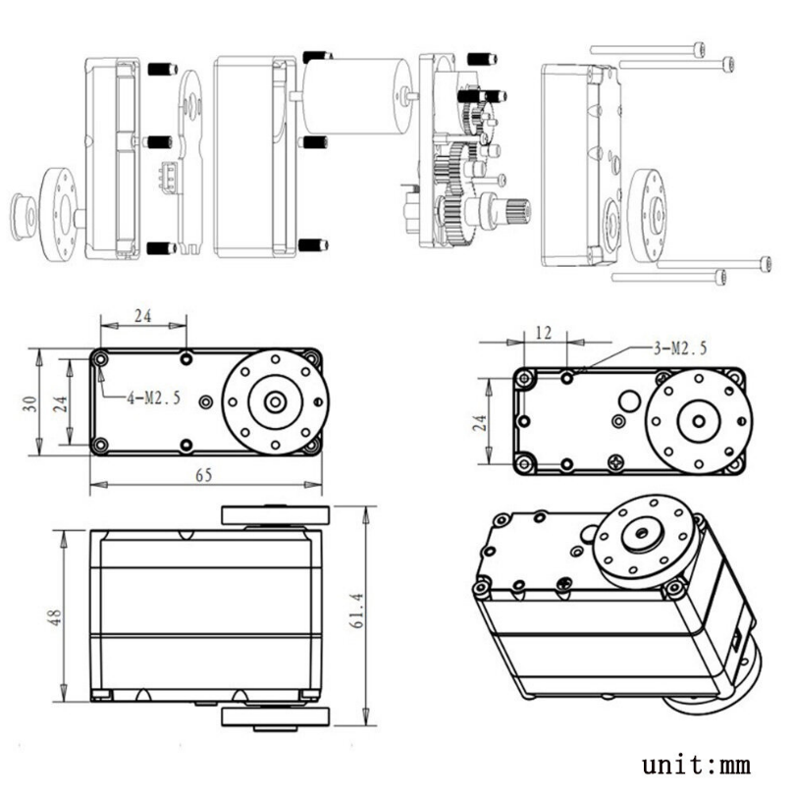

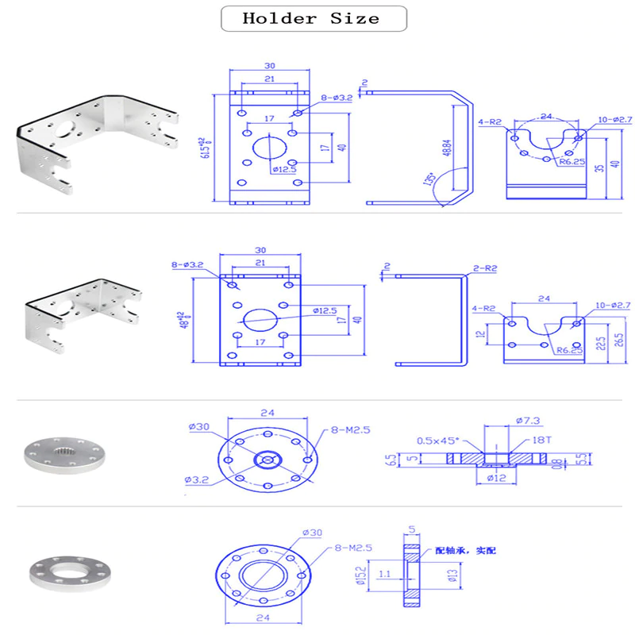

**CAD Drawing – (LD-260mg Motor)**

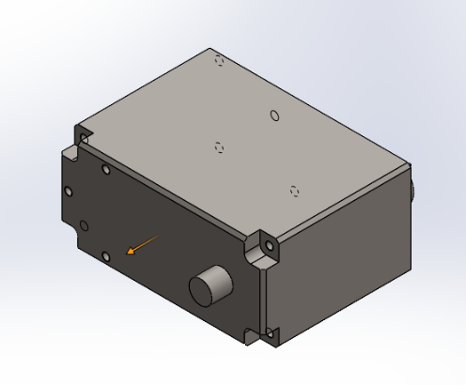

**1- motor Body:**

**2- Main Shaft:**

**3- Bearing:**

**4- Assembly:**

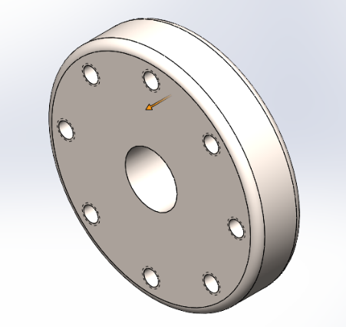

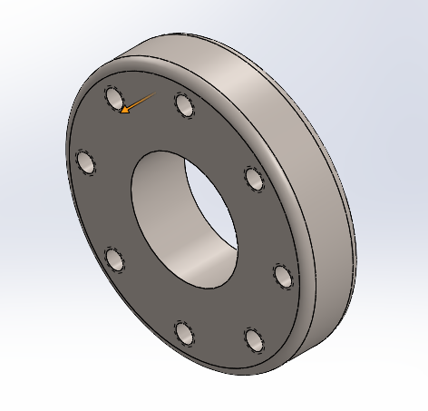

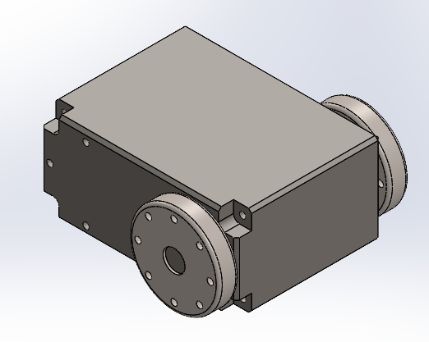

**Forearm design**

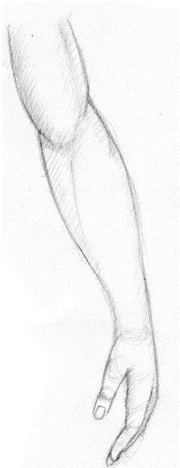

**1- Fictional form**

**2- 1st CAD Drawing (SolidWorks)**

**3-CAD Drawing with (Topology)**

**Topology:** the study of geometrical properties and spatial relations unaffected by the continuous change of shape or size of figures.

**Benefit of Topology: -**

* **Reduce weight**
* **Reduce time to print**
* **Reduce cost**

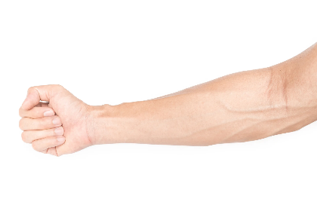

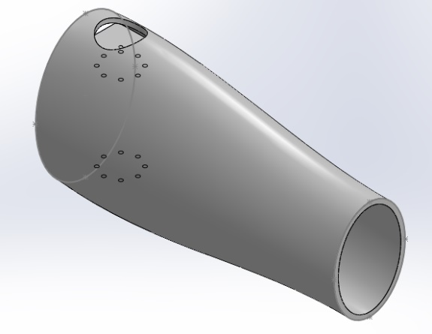

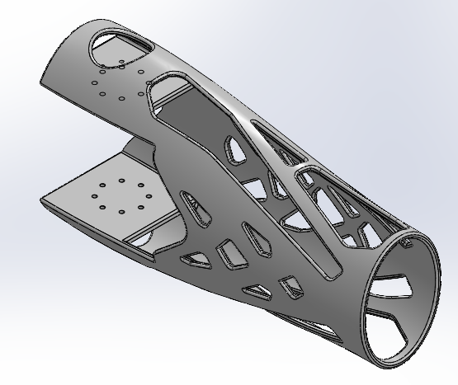

**References:**

<https://ar.banggood.com/LOBOT-LD-260MG-180-60KG-Large-Torque-Metal-Gear-Digital-Servo-For-RC-Robot-p-1516607.html?akmClientCountry=SA&&cur_warehouse=CN>

<https://ar.banggood.com/MG995-High-Torgue-Metal-Gear-Analog-Servo-for-RC-Airplane-Models-p-73885.html?rmmds=search&cur_warehouse=CN>